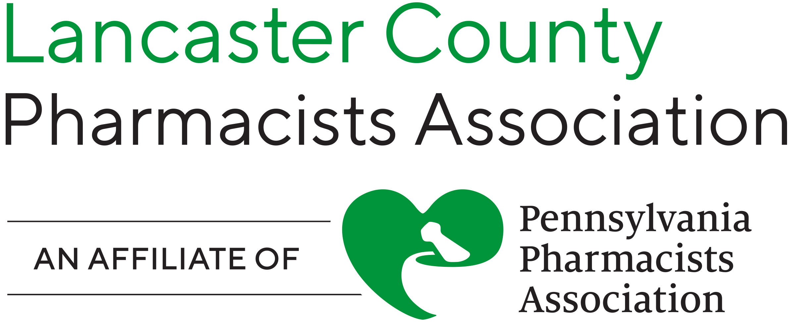

LCPA Upcoming General Meeting!

Tuesday, May 12, 2026

Join us for our next general meeting, sponsored by Amgen Pharmaceuticals!

Repatha for Primary Prevention of CV Events

Location: John J Jeffries, 300 Harrisburg Ave, Lancaster, PA 17603

Start time: 7:30pm

Please RSVP by Friday, May 1st to LCPA -

Email us at lancastercountypharmacists@gmail.com!

We hope to see you there!

