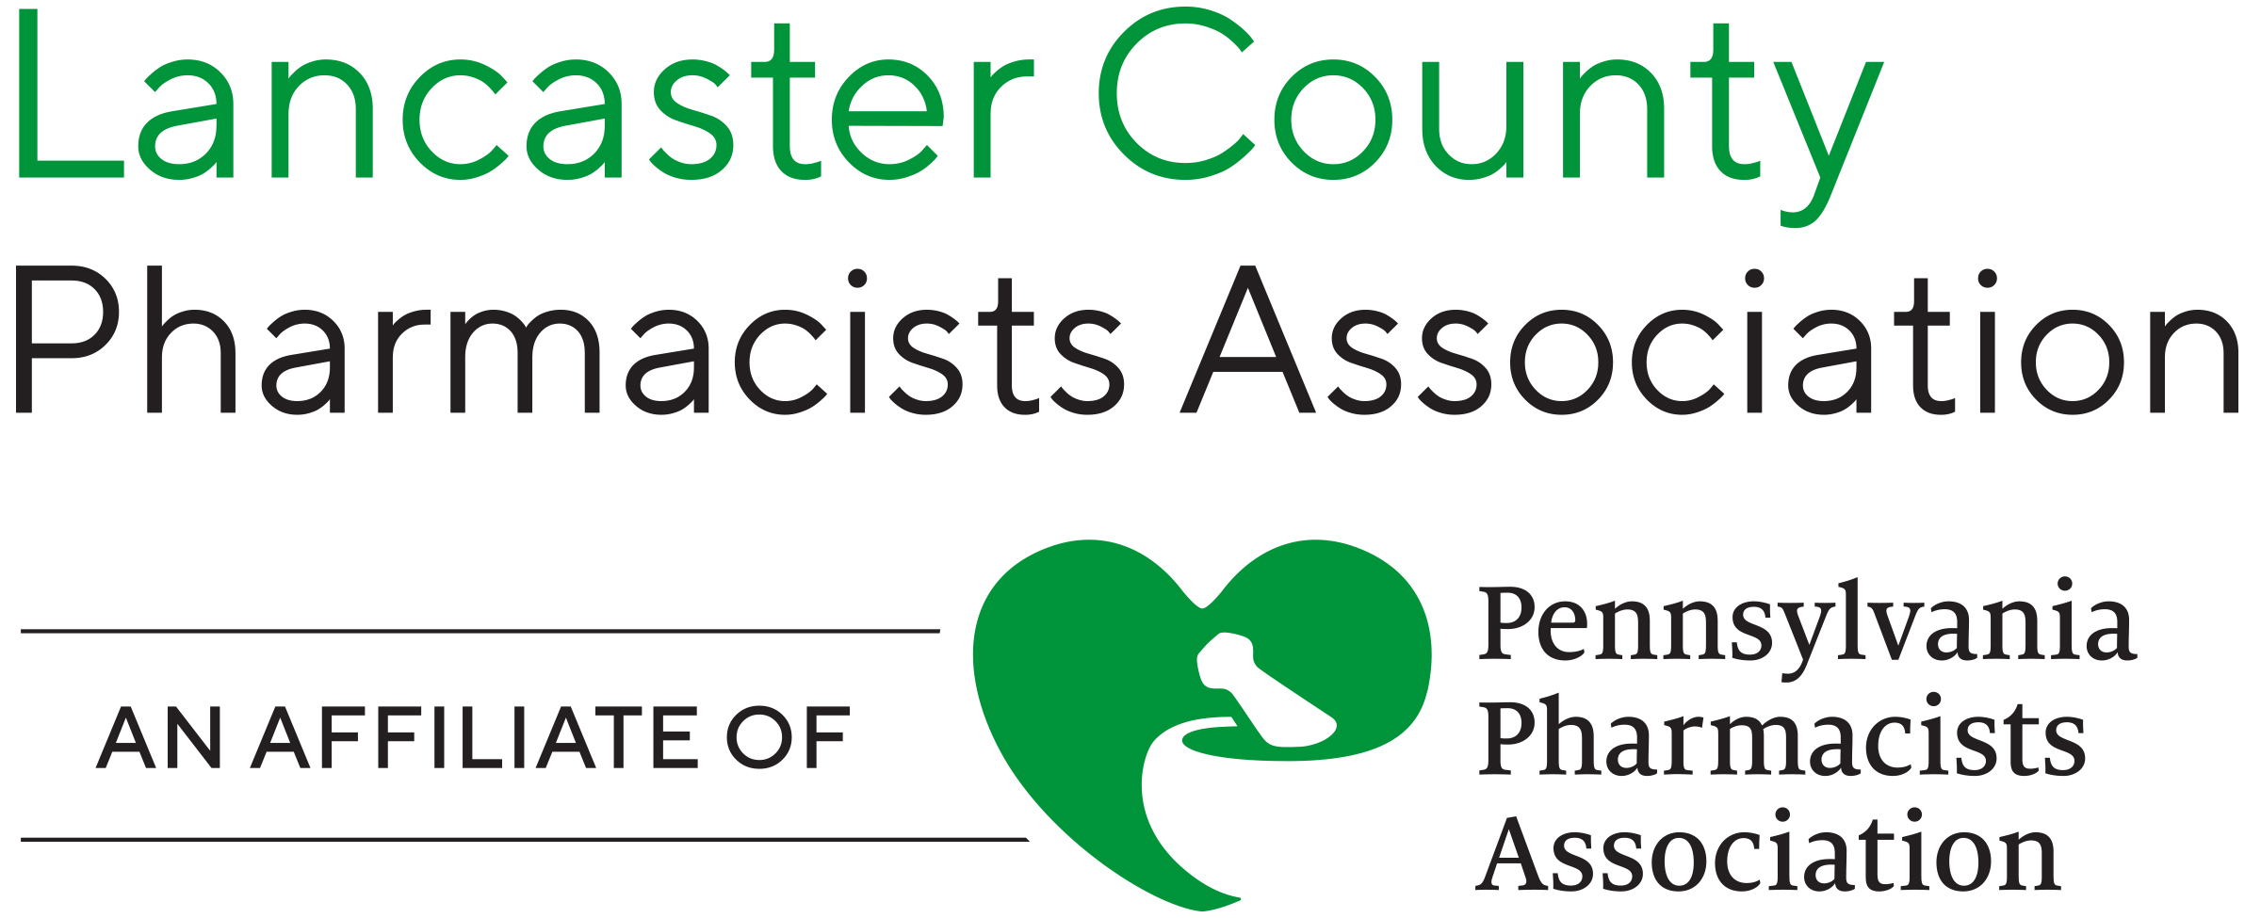

STUDENT SCHOLARSHIP PROGRAM

I am pleased to inform you that the Lancaster County Pharmacists Association will be offering scholarships to qualified pharmacy students.

In order for an applicant to be eligible for a scholarship, he or she must fulfill the following requirements:

- Must be enrolled in an accredited school or college of pharmacy in the United States
- Must be a first, second, third, or fourth professional year pharmacy student
- Must be a resident of Lancaster, Lebanon, or York counties:
- Applicant or parents must have a residence in Lancaster, Lebanon, or York counties.
- Applicant or parents must be taxpayers in Lancaster, Lebanon, or York counties.
- Applicant must be of good moral standing in the community.
- Applicant must complete an official application provided by the Lancaster County Pharmacists Association (available at www.papharmacists.com or www.lancasterpharmacists.com).
- Application must be submitted by April 30th accompanied by an official transcript and a photo.
- After the above requirements are met, the candidate will be required to participate in a personal interview conducted by a member or members of the Scholarship Committee of the Lancaster County Pharmacists Association.

Professionally Yours,
Bob Kayden Jr. R.Ph., Chair
1109 Letort Road
Conestoga, Pa. 17516
717-872-9267 (home)
717-629-9092 (cell)
chiefs89@comcast.net

